Civil war in Sierra Leone

UNSC Resolution: | 1436
Date of adoption: | 24 September 2002
Operative paragraph: | 12
Demand number: | 2

Megan MacKenzie

Wording of demand
continue dialogue and implement their commitments to building regional peace and security

List of addressees of the demand
Government of Sierra Leone

Short-term compliance

Description of the addressee(s)’ conduct
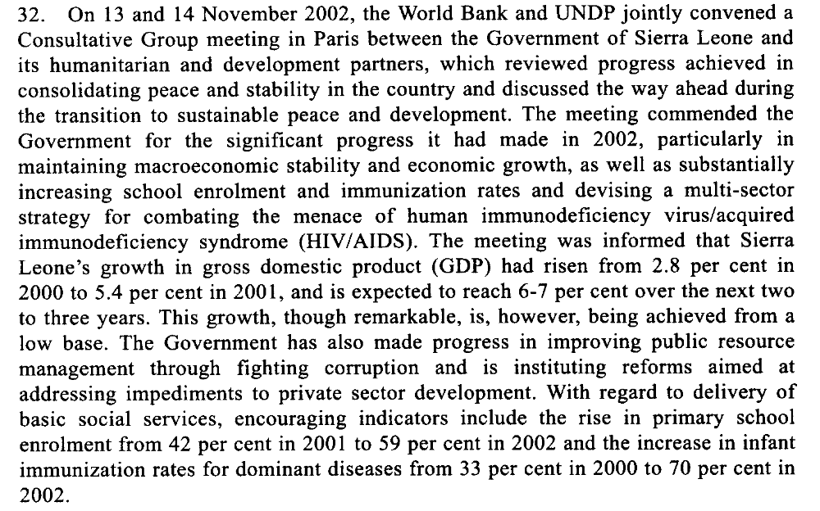

Assessment

Short-term compliance
No or marginal compliance (1) | Medium low compliance (2) | Medium high compliance (3) | x Full or almost full compliance (4)

Considerations underlying the assessment
The Government of Sierra Leone shows strong signs of their commitment to peace. They were commended for their efforts in the areas of education, reintegration, fighting corruption and governance.

Medium-term compliance

Description of the addressee(s)’ conduct

Assessment

Medium-term compliance
No or marginal compliance (1) | Medium low compliance (2) | Medium high compliance (3) | Full or almost full compliance (4)

Considerations underlying the assessment

Depth of demand

Assessment

Level of depth of demand
Low depth of demand (1) | Medium depth of demand (2) | High depth of demand (3)

Considerations underlying the assessment

Level of confidence about coding decisions

Level of confidence about coding decision
Extremely high | High | Moderate

Comments to IPI (if any)

Civil war in Sierra Leone

UNSC Resolution: | 1436
Date of adoption: | 24 September 2002
Operative paragraph: | 13
Demand number: | 1

Megan MacKenzie

Wording of demand
maintain intensive patrolling of the border with Liberia

List of addressees of the demand

Government of Sierra Leone

Short-term compliance

Description of the addressee(s)’ conduct

“The conflict in Liberia remains a major concern for sustained stability in Sierra Leone. During the month of November, there was an upsurge of armed raids by Liberians searching for food in Sierra Leonean villages in the border areas”

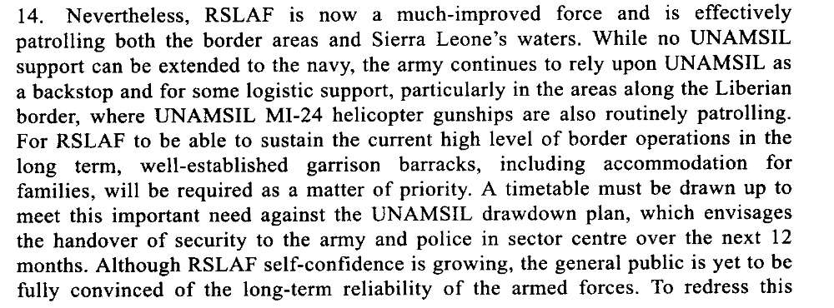

Assessment

Short-term compliance
No or marginal compliance (1) | Medium low compliance (2) | x Medium high compliance (3) | Full or almost full compliance (4)

Considerations underlying the assessment
Despite evidence of border insecurities, the Government showed that it was committed to monitoring the border with Liberia and dedicated forces for this task.

Medium-term compliance

Description of the addressee(s)’ conduct

The military (RSLAF) is faring better [than the police],
even though it is also short on equipment, housing
and training. Its performance in response to border
incursions occasioned by the Liberian civil war has
been erratic and at times unreliable.

8. UNAMSIL is also providing advice to Sierra Leone police in such key
specialized areas as cross-border policing, airport security, criminal intelligence,
policy and planning, family support and juvenile justice, while the United Kingdom
of Great Britain and Northern Ireland and UNDP are leading the efforts to equip the
police and rehabilitate the police infrastructure throughout the country. With the
support of UNAMSIL, the police force has now established a diamonds crime
intelligence and investigation unit, but efforts to recruit a United Nations civilian
police diamond adviser have not been successful.

Assessment

Medium-term compliance
No or marginal compliance (1) | x Medium low compliance (2) | Medium high compliance (3) | Full or almost full compliance (4)

Considerations underlying the assessment
In the long term, border security was still a security issue for Sierra Leone and the Government required assistance from other parties to monitor the border.

Depth of demand

Assessment

Level of depth of demand
Low depth of demand (1) | x Medium depth of demand (2) | High depth of demand (3)

Considerations underlying the assessment

Although it was in the interests of the Government to monitor the border, due to the security situation in Liberia and the crossover of fighters from Liberia to Sierra Leone throughout the war, it was difficult to secure and monitor this border.

Level of confidence about coding decisions

Level of confidence about coding decision
Extremely high | x High | Moderate

Comments to IPI (if any)

Civil war in Sierra Leone

UNSC Resolution: | 1436
Date of adoption: | 24 September 2002
Operative paragraph: | 14
Demand number: | 1

Megan MacKenzie

Wording of demand
pay special attention to the needs of women and children affected by the war, as outlined in paragraphs 47 to 48 of the report of the Secretary-General of 5 September 2002 (S/2002/987)

List of addressees of the demand
Government of Sierra Leone

Short-term compliance

Description of the addressee(s)’ conduct
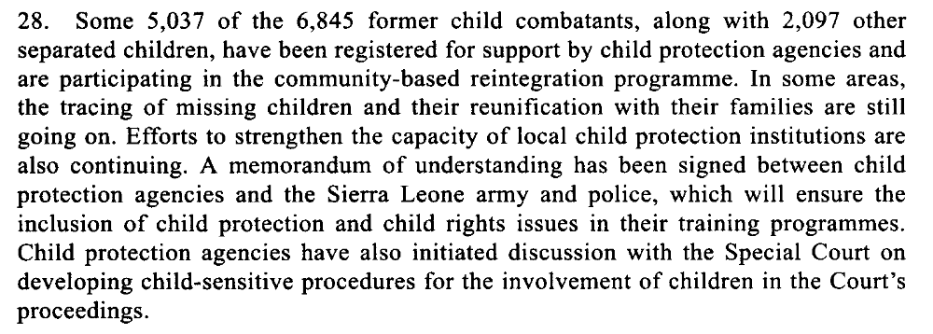

Assessment

Short-term compliance
No or marginal compliance (1) | Medium low compliance (2) | Medium high compliance (3) | x Full or almost full compliance (4)

Considerations underlying the assessment

Child soldiers were given special attention and special agencies and measures were taken to address the needs of children post-conflict.

Medium-term compliance

Description of the addressee(s)’ conduct

Assessment

Medium-term compliance
No or marginal compliance (1) | Medium low compliance (2) | Medium high compliance (3) | Full or almost full compliance (4)

Considerations underlying the assessment

Depth of demand

Assessment

Level of depth of demand
Low depth of demand (1) | Medium depth of demand (2) | High depth of demand (3)

Considerations underlying the assessment

Level of confidence about coding decisions

Level of confidence about coding decision
Extremely high | High | Moderate

Comments to IPI (if any)

Civil war in Sierra Leone

UNSC Resolution: | 1436
Date of adoption: | 24 September 2002
Operative paragraph: | 15
Demand number: | 1

Megan MacKenzie

Wording of demand
take the necessary measures to bring to justice their own nationals responsible for such crimes

List of addressees of the demand
Government of Sierra Leone

Short-term compliance

Description of the addressee(s)’ conduct

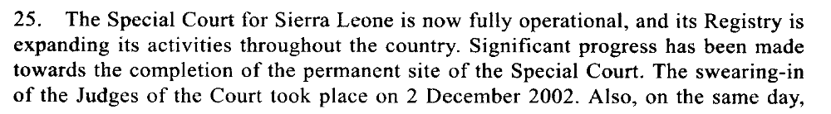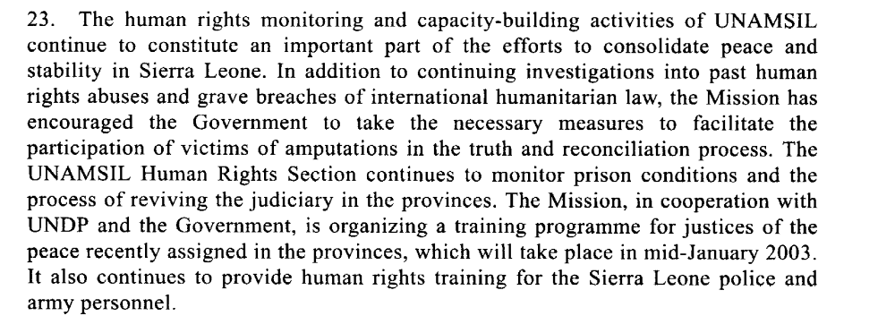

Assessment

Short-term compliance
No or marginal compliance (1) | Medium low compliance (2) | x Medium high compliance (3) | Full or almost full compliance (4)

Considerations underlying the assessment
At this time the Government had established several mechanisms, including the Special Court and the Human Rights Commission to investigate and bring justice to perpetrators in the country.

Medium-term compliance

Description of the addressee(s)’ conduct

42. The overall human rights situation in Sierra Leone has improved since the end
of the war in early 2002. Steps are being taken to increase access to justice, although
major challenges remain in this area. Substantial improvements in the conditions of
detention in police stations and prisons have been achieved due to regular
monitoring. Similar monitoring of magistrate courts has also had a positive impact
on the backlog of cases pending before the courts. The Truth and Reconciliation
Commission has completed its work and is now finalizing its report, which is
expected to be published in May 2004. Many Sierra Leoneans acknowledge that the
Truth and Reconciliation Commission has had the desired cathartic effect. However,
views are somewhat divided on whether the work of the Special Court will have a
similar healing impact.
43. Despite the above-mentioned gains, there are key human rights issues that need
to continue to be monitored and addressed. In particular, the causes and effects of
the human rights crisis emanating from a decade of war are yet to be adequately
addressed. In this context, many Sierra Leonean and international stakeholders have
expressed concern about the human rights implications of the weak capacity of the
country’s justice system. This and other challenges, coupled with corrupt practices,
impede the effective, efficient and equitable delivery of justice.
44. Reform of the justice sector needs to be pursued with the aim of ensuring
access to justice for the poor, rural communities and vulnerable segments of the
society, in particular women and children. The United Kingdom-sponsored Safety,
Security and Access to Justice programme contributes to these important objectives
through support for building the capacity of the justice sector. However, concern has
also been expressed about the lack of progress on law review and reform. Old laws
that include gender and other forms of discrimination are still on the books. In
addition, the Government needs assistance on law reporting. Judicial authorities
continue to have little or no access at all to current legislation and jurisprudence.
The Minister of Justice and the Attorney-General informed the assessment mission
that the last law report was issued in 1973 and emphasized that the publication of
the country’s laws is vital to the promotion of the rule of law.
45. Violence against women, including sexual exploitation, as well as
discrimination against women in law and in practice and the low rate of
participation of women and youth in the political and administrative affairs of the
country, needs to be addressed.

Assessment

Medium-term compliance
No or marginal compliance (1) | Medium low compliance (2) | x Medium high compliance (3) | Full or almost full compliance (4)

Considerations underlying the assessment
The TRC, Special Court and the Human Rights Commission were still in process; however, the Government was still lacking some of the logistical support needed to investigate and bring perpetrators to justice.

Depth of demand

Assessment

Level of depth of demand
Low depth of demand (1) | x Medium depth of demand (2) | High depth of demand (3)

Considerations underlying the assessment

Due to the length of the war and the number of perpetrators, bringing justice to perpetrators required significant resources and logistical commitments.

Level of confidence about coding decisions

Level of confidence about coding decision
Extremely high | x High | Moderate

Comments to IPI (if any)

Civil war in Sierra Leone

UNSC Resolution: | 1436
Date of adoption: | 24 September 2002
Operative paragraph: | 16
Demand number: | 2

Megan MacKenzie

Wording of demand
continue to cooperate to this end to fulfil their commitments under the Abuja Ceasefire Agreement of 10 November 2000 (S/2000/1091)

List of addressees of the demand
Government of Sierra Leone, Revolutionary United Front

Short-term compliance

Description of the addressee(s)’ conduct
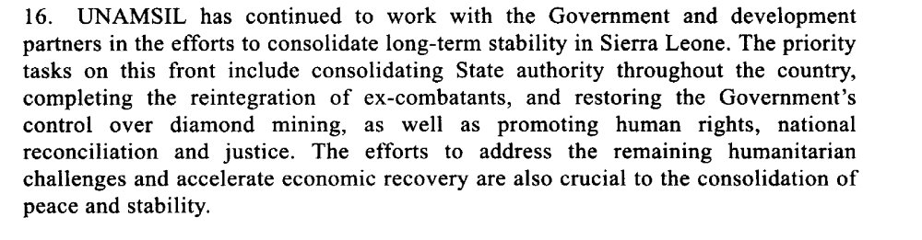

Assessment

Short-term compliance
No or marginal compliance (1) | Medium low compliance (2) | Medium high compliance (3) | x Full or almost full compliance (4)

Considerations underlying the assessment

Major strides were made in terms of reintegration, justice, and the consolidation of authority during this time.

Medium-term compliance

Description of the addressee(s)’ conduct

Assessment

Medium-term compliance
No or marginal compliance (1) | Medium low compliance (2) | Medium high compliance (3) | Full or almost full compliance (4)

Considerations underlying the assessment

Depth of demand

Assessment

Level of depth of demand
Low depth of demand (1) | Medium depth of demand (2) | High depth of demand (3)

Considerations underlying the assessment

Level of confidence about coding decisions

Level of confidence about coding decision
Extremely high | High | Moderate

Comments to IPI (if any)

Civil war in Sierra Leone

UNSC Resolution: | 1470
Date of adoption: | 28 March 2003
Operative paragraph: | 7
Demand number: | 2

Megan MacKenzie

Wording of demand
accelerate the consolidation of civil authority and public services throughout the country, and strengthen the operational effectiveness and capabilities of the security sector

List of addressees of the demand
Government of Sierra Leone

Short-term compliance

Description of the addressee(s)’ conduct

21. The deployment of government officials to all districts was completed during
the reporting period. However, the capacity of government structures to deliver
services in the provinces remains feeble, owing to challenges posed by logistic and
infrastructure constraints, as well as the lack of qualified personnel. The
infrastructure constraints are being addressed through the rehabilitation of district
offices in some areas. In an effort to address the logistics challenges, the
Government recently provided vehicles to some district offices. Nevertheless, the
continuing lack of basic facilities and equipment still hampers the effective
functioning of most government structures in the provinces.
22. The Government continues to devote considerable attention to the issue of
decentralization of local government. The nationwide district consultations on
decentralization and local government reform were completed in April. The
consultations enabled the Government to seek opinions on issues such as the nature
and type of local government structures to be put in place, and the type of local
elections to be conducted in the near future. In a commendable initiative intended to
bring the Government closer to the people, President Kabbah has started holding
cabinet sessions in the provincial and district capitals.

Assessment

Short-term compliance
No or marginal compliance (1) | Medium low compliance (2) | x Medium high compliance (3) | Full or almost full compliance (4)

Considerations underlying the assessment
The Government had made progress in extending its authority; however it still lacked some of the logistical skills and abilities needed for good governance.

Medium-term compliance

Description of the addressee(s)’ conduct

22. Government officials from the relevant line ministries have been deployed in
all 12 administrative districts of the country, and paramount chiefs have returned to
their chiefdoms. The 64 paramount chief posts that fell vacant during the conflict
were filled through elections held from 2 December 2002 to 24 January 2003. The
presence of a better-equipped and more disciplined national police force is now
visible in the provinces and, as indicated earlier, district and provincial security
committees are being set up throughout the country.
23. Magistrate courts have been rehabilitated in all districts, and they are now
sitting in the district and provincial headquarters, albeit with inadequate coverage.
The recruitment of judges and magistrates has been hampered by the existing
unattractive conditions of service. There are only five magistrates assigned to
service a total of 12 districts. As a temporary measure, justices of the peace have
been trained, with the support of UNDP, and deployed to some 18 locations where
they perform judicial functions under the supervision of those magistrates.
24. Considering that only two years ago the extent of State authority was limited
to about one third of the country, the progress made in re-establishing government
administrative, security and judicial structures throughout the country is remarkable.
Nonetheless, the capacity of those structures to function effectively remains severely
limited due to the lack of logistics, infrastructure and qualified personnel. There is
also concern that the district councils expected to be elected in May will likely face
similar constraints, which could render ineffectual the efforts to decentralize the
functions of the central Government. However, the World Bank, the Department for
International Development, UNDP, the European Union and the United States
Agency for International Development have indicated that they would provide
capacity-building support to the councils and to the decentralization process in
general.

Assessment

Medium-term compliance
No or marginal compliance (1) | Medium low compliance (2) | x Medium high compliance (3) | Full or almost full compliance (4)

Considerations underlying the assessment

Despite some remaining logistical challenges, the Government had extended its authority across the country and developed its capacity.

Depth of demand

Assessment

Level of depth of demand
x Low depth of demand (1) | Medium depth of demand (2) | High depth of demand (3)

Considerations underlying the assessment

This demand asked the party to continue behavior that was well supported by the international community.

Level of confidence about coding decisions

Level of confidence about coding decision
Extremely high | x High | Moderate

Comments to IPI (if any)

Civil war in Sierra Leone

UNSC Resolution: | 1470
Date of adoption: | 28 March 2003
Operative paragraph: | 9
Demand number: | 1

Megan MacKenzie

Wording of demand
consider urgently relevant policy options for more effective regulation and control of diamond mining activities, and adopt and implement such a policy as soon as possible

List of addressees of the demand
Government of Sierra Leone

Short-term compliance

Description of the addressee(s)’ conduct

5. The influx of a large number of young men to the diamond mining areas of
Kono district and Tongo Fields, and the activities of local militant youth groups who
resent the influx of “outsiders” also remain a potential source of instability. As a
result of inadequate State policing in these areas, the youth groups, whose
membership consists mainly of former combatants, have continued to challenge the
local authorities. In early June, the Government formed a Task Force headed by the
Secretary to the President, with responsibilities for ensuring that unregulated mining
activity is brought under effective control in order to minimize the threat it poses to
the country
24. There has been a significant increase in licensed mining activities and in
official exports of rough diamonds during the period under review. More
government mining officers and monitors have been deployed to the diamond
mining areas. Official exports are reported to have reached $28 million between
January and May 2003. However, there is ample evidence that illicit mining persists
in many parts of the country. Furthermore, in spite of advances in this regard, the
Government has yet to put in place a comprehensive legislative framework and a
mining policy for more effective control and regulation of diamond mining
activities.

Assessment

Short-term compliance
No or marginal compliance (1) | x Medium low compliance (2) | Medium high compliance (3) | Full or almost full compliance (4)

Considerations underlying the assessment

Illicit mining, violence, and corruption were still rampant in the diamond regions and the Government had still failed to implement a legislative framework for monitoring and regulating diamond activities.

Medium-term compliance

Description of the addressee(s)’ conduct

7. To date, some 980 police recruits have been trained, bringing the strength of
the Sierra Leone police to 7,115 as of February 2004. The newly trained police
personnel are being deployed to the provinces, focusing on areas vacated by
UNAMSIL and the sensitive diamond-mining and border areas in the east of the
country.
8. UNAMSIL is also providing advice to Sierra Leone police in such key
specialized areas as cross-border policing, airport security, criminal intelligence,
policy and planning, family support and juvenile justice, while the United Kingdom
of Great Britain and Northern Ireland and UNDP are leading the efforts to equip the
police and rehabilitate the police infrastructure throughout the country. With the
support of UNAMSIL, the police force has now established a diamonds crime
intelligence and investigation unit, but efforts to recruit a United Nations civilian
police diamond adviser have not been successful.

Assessment

Medium-term compliance
No or marginal compliance (1) | Medium low compliance (2) | x Medium high compliance (3) | Full or almost full compliance (4)

Considerations underlying the assessment

The Government continued to dedicate resources and security personnel to this area.

Depth of demand

Assessment

Level of depth of demand
x Low depth of demand (1) | Medium depth of demand (2) | High depth of demand (3)

Considerations underlying the assessment

Level of confidence about coding decisions

Level of confidence about coding decision
Extremely high | x High | Moderate

Comments to IPI (if any)

Civil war in Sierra Leone

UNSC Resolution: | 1470
Date of adoption: | 28 March 2003
Operative paragraph: | 13
Demand number: | 3?

Megan MacKenzie

Wording of demand
resume dialogue and implement their commitments to building regional peace and security

List of addressees of the demand
Government of Sierra Leone

Short-term compliance

Description of the addressee(s)’ conduct

65. The gradual and carefully calibrated approach to the drawdown of UNAMSIL,
as approved by the Security Council, is yielding the desired benefits. In particular,
the extended presence of the Mission in the country has assured a stable security
environment and enabled the Government to make steady progress in consolidating
peace, and in promoting national reconciliation, justice and national reconstruction.
Tangible progress has been made in the efforts to consolidate peace, including the
reintegration of some 48,000 out of the 57,000 disarmed ex-combatants, the
completion of the resettlement of internally displaced persons, the acceleration of
the repatriation and resettlement of Sierra Leonean refugees

Assessment

Short-term compliance
No or marginal compliance (1) | Medium low compliance (2) | Medium high compliance (3) | Full or almost full compliance (4)

Considerations underlying the assessment

Medium-term compliance

Description of the addressee(s)’ conduct

Assessment

Medium-term compliance
No or marginal compliance (1) | Medium low compliance (2) | Medium high compliance (3) | Full or almost full compliance (4)

Considerations underlying the assessment

Depth of demand

Assessment

Level of depth of demand
Low depth of demand (1) | Medium depth of demand (2) | High depth of demand (3)

Considerations underlying the assessment

Level of confidence about coding decisions

Level of confidence about coding decision
Extremely high | High | Moderate

Comments to IPI (if any)

United Nations Security Council, 'Strengthening the Security Sector' Sixteenth Report of the Secretary-General on the United Nations Mission in Sierra Leone, S/2002/1417, 24 December 2002.
United Nations Secretary-General. Sixteenth report of the Secretary General on the United Nations Mission in Sierra Leone 24 December 2002.
International Crisis Group. Sierra Leone: The State of Security and Governance. ICG Africa Report No 67. Freetown/London/Brussels. 3 September 2003. P5.
U.N. Security Council, ’25/26 Restoration of Government Control over diamond mining activities’, in Twenty-first report of the Secretary-General of the United Nations Mission in Sierra-Leone, (S/19/03/2004/228), pp. 3.
United Nations Secretary-General. Sixteenth report of the Secretary General on the United Nations Mission in Sierra Leone 24 December 2002.
United Nations Secretary-General. Twenty-first report of the Secretary-General on the United Nations Mission in Sierra Leone. 19 March 2004.
United Nations Secretary-General. Sixteenth report of the Secretary General on the United Nations Mission in Sierra Leone 24 December 2002.
United Nations Secretary-General. Eighteenth Report of the Secretary-General on the United Nations Mission in Sierra Leone 23 June 2003.
United Nations Secretary-General. Twenty-first report of the Secretary-General on the United Nations Mission in Sierra Leone. 19 March 2004.
United Nations Secretary-General. Eighteenth Report of the Secretary-General on the United Nations Mission in Sierra Leone 23 June 2003.
United Nations Secretary-General. Twenty-first report of the Secretary-General on the United Nations Mission in Sierra Leone. 19 March 2004.
United Nations Secretary-General. Eighteenth Report of the Secretary-General on the United Nations Mission in Sierra Leone 23 June 2003.
United Nations Security Council, 'Humanitarian, Recovery and Development Challenges' Sixteenth Report of the Secretary-General on the United Nations Mission in Sierra Leone, (S/2002/1417, 24 December 2002), pp.9.
United Nations Security Council, 'Humanitarian, Recovery and Development Challenges', Sixteenth Report of the Secretary-General on the United Nations Mission in Sierra Leone. (S/2002/1417, 24 December 2002),pp.8.

